Name: ___________________________________________________ Date: _____________________

AP Calculus AB: Unit 7 Day32 HW Visca

In Exercises 1–6, find the area of the shaded region analytically.

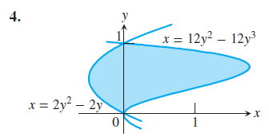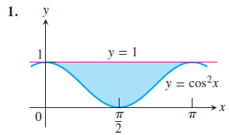

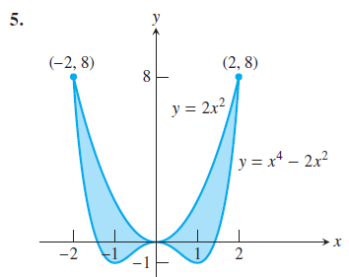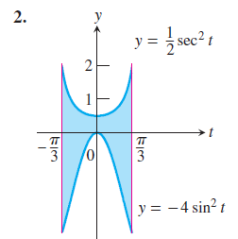

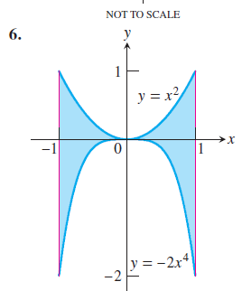

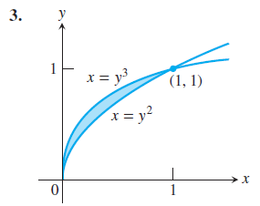

In Exercises 13 and 14, find the total shaded area.

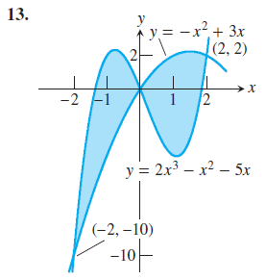

In Exercises 15–34, find the area of the regions enclosed by the lines and curves.





